National University of Computer and Emerging Sciences



Lab Manual # 01
Digital Logic Design (EL1005)

Course Instructor | Mr. Haris Jamil
Lab Instructor(s) | Mr. Zummar Saad  Mr. Salman Mubarik
Section | BDS-2D
Semester | Spring 2022

Department of Computer Science
FAST-NU, Lahore, Pakistan
Objectives:
- To learn and understand the working of NAND gate and NOR gate
- SOP expressions from K-map
Introduction to NAND Gate
74LS00 IC contains four 2-input NAND gates. The function table and connection diagram for this IC are shown below:
Function TableConnection Diagram:
Inputs |  | Output
A | B | Y
L | L | H
L | H | H
H | L | H
H | H | L
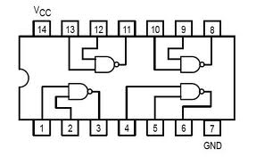
H= Logic High, L= Logic Low

Introduction to NOR Gate
74LS02 IC contains four 2-input NOR gates. The function table and connection diagram for this IC are shown below:
Function Table:Connection Diagram:

Inputs |  | Output
A | B | Y
L | L | H
L | H | L
H | L | L
H | H | L
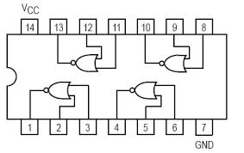
H= Logic High, L= Logic Low
NOR and NAND Implementation on logic trainer:
Question#1: Implement the ANDand OR gate using only the NAND gates
- Z=A.B b. X=A+B c. XOR Gate

Question#2: Implement the AND and OR gate using only the NOR gates
- Z=A.B b. X=A+B c. XNOR Gate

Question # 3:For the Boolean function $F1(A,B,C,D)=\sum{m(2,4,12,14)}$ do the following:
- Find truth table

- Find minimal SOP expression for Boolean function $F1$ using K-map. Draw K-map in the space given below. Implement it on logic trainer.

